**Installing Pivotal Cloud Foundry on AWS**

Ref: <https://docs.pivotal.io/pivotalcf/1-10/customizing/cloudform.html/>

* This guide describes how to install [Pivotal Cloud Foundry](https://network.pivotal.io/products/pivotal-cf) (PCF) on Amazon Web Services (AWS) using the PCF CloudFormation template.

## Install PCF on AWS

Complete the following procedures to install PCF using CloudFormation:

1. [Deploying the CloudFormation Template for PCF on AWS](https://docs.pivotal.io/pivotalcf/1-7/customizing/cloudform-template.html)
2. [Launching an Ops Manager Director Instance on AWS](https://docs.pivotal.io/pivotalcf/1-7/customizing/cloudform-om-deploy.html)
3. [Configuring Ops Manager Director on AWS](https://docs.pivotal.io/pivotalcf/1-7/customizing/cloudform-om-config.html)
4. [(Optional) Installing the PCF IPsec Add-On](http://docs.pivotal.io/addon-ipsec/installing.html)
5. [Deploying Elastic Runtime on AWS](https://docs.pivotal.io/pivotalcf/1-7/customizing/cloudform-er-config.html)
6. **Deploying the CloudFormation Template for Pivotal Cloud Foundry on AWS**
7. Step 1: Download the PCF CloudFormation Template
8. Step 2: Upload an SSL Certificate to AWS
   1. (Option) Create SSL Certificate using the AWS CLI
   2. (Option) Create SSL Certificate using the AWS Certificate Manager
9. Step 3: Create a Resource Stack Using the CloudFormation Template

The template is designed to output the resources necessary for two availability zones (AZ), with a private and public subnet designated for each AZ. The Elastic Load Balancer will be attached to the public subnet of both AZs to balance traffic across both environments

Step 1: Download the PCF CloudFormation Template:

1. Sign in to [Pivotal Network](https://network.pivotal.io/).
2. Select **Elastic Runtime**. From the **Releases** drop-down menu, select the release that you wish to install.
3. Download the **PCF 1.7 CloudFormation script for AWS**.
4. Save the file as pcf.json.

Step 2: Upload an SSL Certificate to AWS

You can add an SSL Certificate using two methods:

* The [AWS Certificate Manager](https://docs.pivotal.io/pivotalcf/1-7/customizing/cloudform-template.html#aws-certificate-manager)
* create a certificate, must use your system wildcard domain (example: *.my-pcf-apps-domain.com) as the Common Name input.
* Add the following additional domains and wildcards using OpenSSL’s SAN (subjectAltName) extension: *.system.yourdomain.com, *.login.system.yourdomain.com, *.uaa.system.yourdomain.com, and *.apps.yourdomain.com

Ref:

*.e-cloudenabled.com

*.system.e-cloudenabled.com, *.login.system.e-cloudenabled.com, *.uaa.system.e-cloudenabled.com, *.apps.e-cloudenabled.com

Step 3: Create a Resource Stack Using the CloudFormation Template

**05RdsUserName: sushil**

**06RdsPassword:** **sushil123**

1. Log in to the [AWS Console](https://console.aws.amazon.com/).
2. In the second column, under **Management Tools**, click **CloudFormation**.

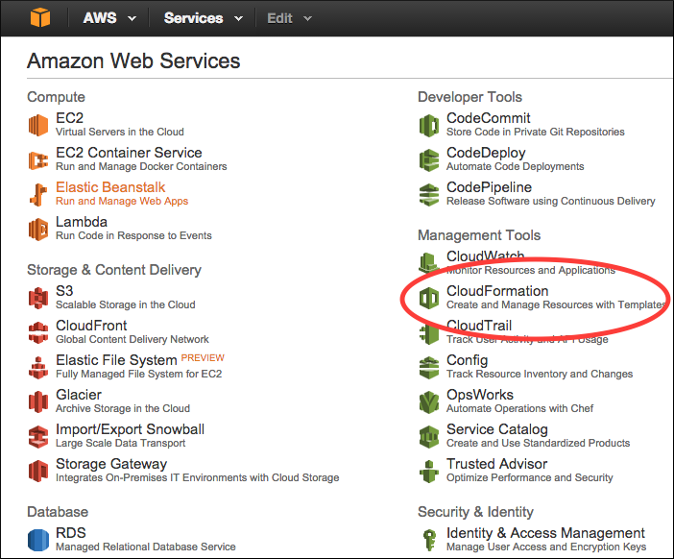

1. Click **Create New Stack**.

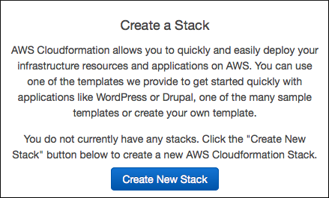

1. Select **Upload a template to Amazon S3**.

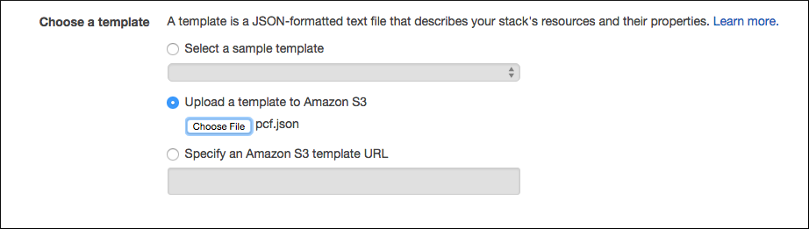

1. Click **Browse**. Browse to and select the pcf.json, the **Pivotal Cloud Foundry CloudFormation script for AWS** file that you downloaded. Click **Next**.
2. On the next screen, name the stack pcf-stack.
3. In the **Specify Parameters** page, complete the following fields:

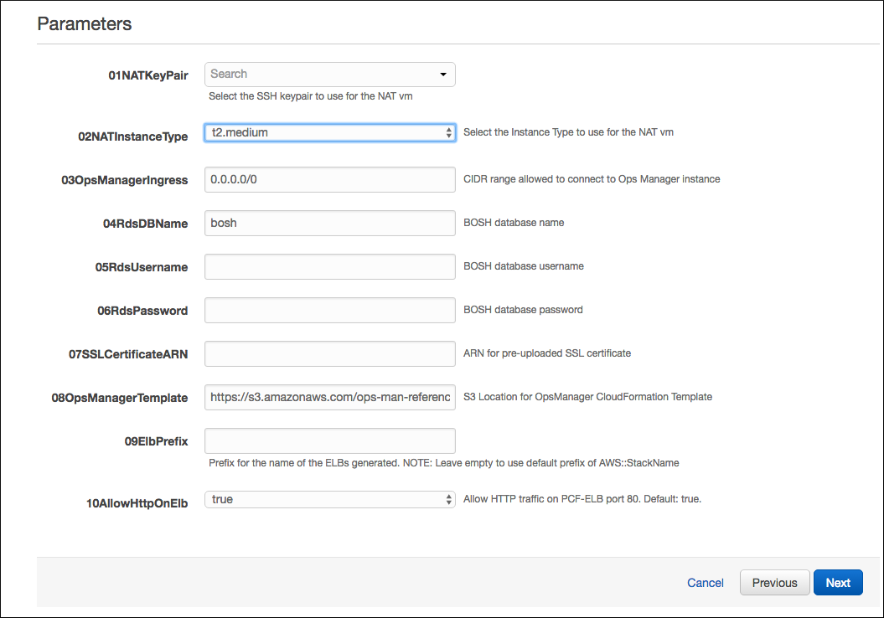

* + **01NATKeyPair**: Use the drop-down menu to select the name of your pre-existing AWS key pair. If you do not have a pre-existing key pair, create one in [AWS](http://docs.aws.amazon.com/AWSCloudFormation/latest/UserGuide/cfn-console-create-keypair.html) and return to this step.
  + **02NATInstanceType**: Do not change this value.
  + **03OpsManagerIngress**: Do not change this value.

**Note**: The first parameter name begins with 03.

* + **04RdsDBName**: Do not change this value.
  + **05RdsUserName**: Enter a username for the RDS database.

**Note**: Do not enter the username rdsadmin. AWS reserves the rdsadmin user account for internal database instance management.

* + **06RdsPassword**: Enter a password for the RDS database.
  + **07SSLCertificateARN**: Enter your uploaded SSL Certificate ARN.
  + **08OpsManagerTemplate**: The default template link provided here works. Otherwise you can enter your own S3 bucket location of the Ops Manager CloudFormation script.
  + **09ElbPrefix**: Prefix for the generated names of the ELBs. Any string you specify in this field will be prefixed to -pcf-elb to form the name of your ELBs. Leave empty to use the default prefix of AWS::StackName.
  + **10AllowHttpOnElb**: Set this to true to listen for HTTP traffic on port 80. This is the default. Set it to false to only listen for traffic on ports 443 and 4443.

1. Click **Next**.
2. On the **Options** page, leave the fields blank and click **Next**.

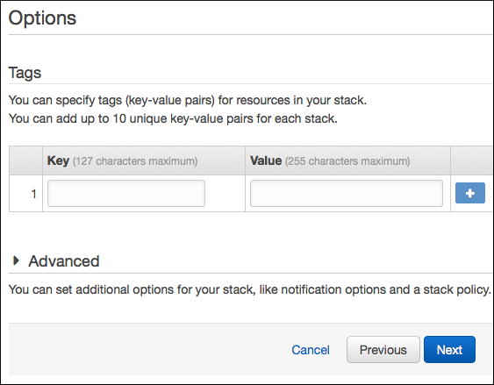

1. On the **Review** page, select the **I acknowledge that this template might cause AWS CloudFormation to create IAM resources** checkbox and click **Create**.

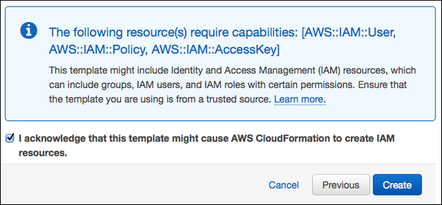

AWS runs the CloudFormation script and creates the infrastructure that you need to deploy PCF to AWS. This may take a few moments. You can click on the **Events** tab to view the progress of the setup.

When the installation process successfully completes, AWS displays **CREATE_COMPLETE** as the status of the stack.

# Launching an Ops Manager Director Instance on AWS

[Step 1: Open the Outputs Tab in AWS Stacks](https://docs.pivotal.io/pivotalcf/1-10/customizing/cloudform-om-deploy.html#outputs)

[Step 2: Select a Pivotal Ops Manager AMI Instance](https://docs.pivotal.io/pivotalcf/1-10/customizing/cloudform-om-deploy.html#select-ami)

[Step 3: Configure Instance Details](https://docs.pivotal.io/pivotalcf/1-10/customizing/cloudform-om-deploy.html#configure-instance)

[Step 4: Configure Security Group](https://docs.pivotal.io/pivotalcf/1-10/customizing/cloudform-om-deploy.html#security-group)

[Step 5: Deploy Ops Manager](https://docs.pivotal.io/pivotalcf/1-10/customizing/cloudform-om-deploy.html#deploy)

[Step 6: Create a DNS Entry](https://docs.pivotal.io/pivotalcf/1-10/customizing/cloudform-om-deploy.html#create-dns)

[Step 7: Configure Ops Manager Director for AWS](https://docs.pivotal.io/pivotalcf/1-10/customizing/cloudform-om-deploy.html#configure)

[Step 1: Open the Outputs Tab in AWS Stacks](https://docs.pivotal.io/pivotalcf/1-10/customizing/cloudform-om-deploy.html#outputs)

1. In the dashboard of your [AWS Console](https://console.aws.amazon.com/), click **CloudFormation**. The Stacks Dashboard displays.
2. Select the **pcf-stack** checkbox, then select the **Outputs** tab.

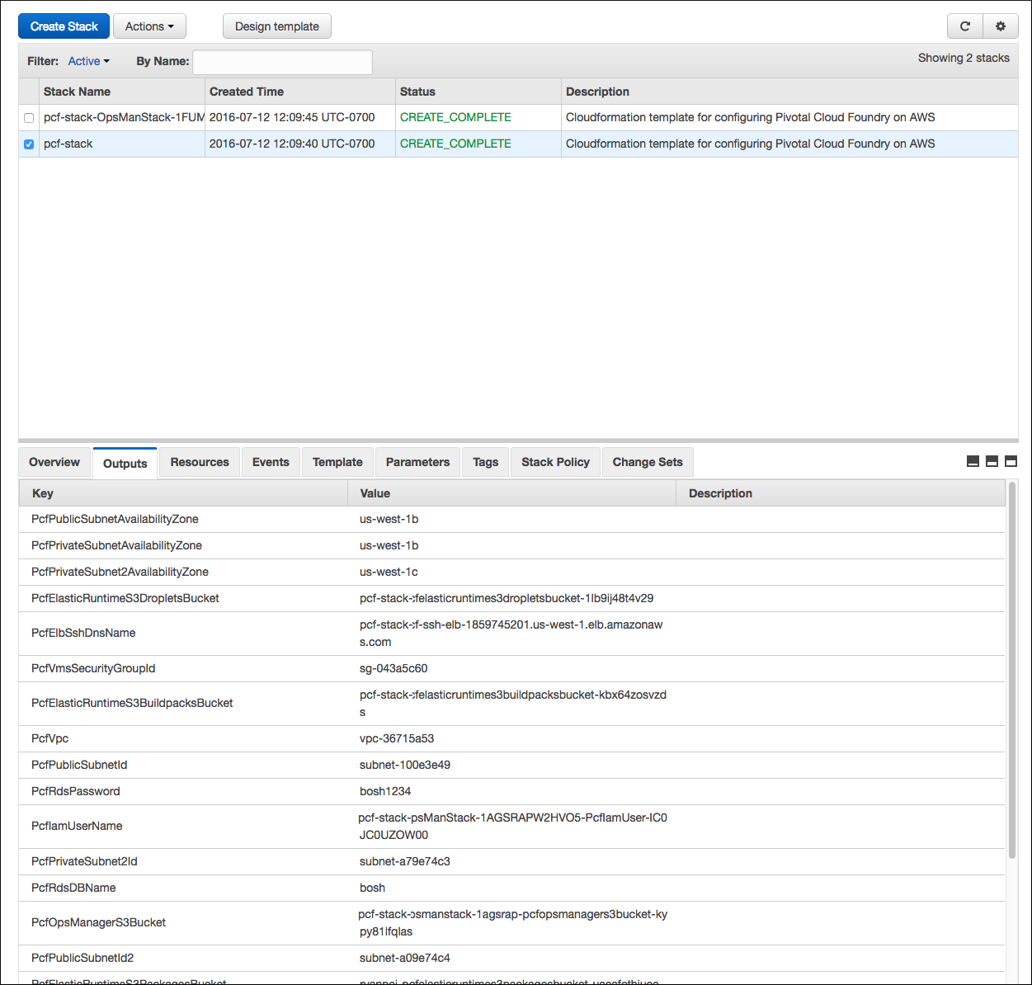

In the steps described below, use the information from the **Value** column of the **Outputs** tab to configure your PCF installation.

Step 2: Select a Pivotal Ops Manager AMI Instance

ami-5baaaa3d

1. Log in to the [Pivotal Network](https://network.pivotal.io/products/pivotal-cf) and click Pivotal Cloud Foundry **Ops Manager**.
2. From the **Releases** dropdown, select the release to install.
3. Select **Pivotal Cloud Foundry Ops Manager for AWS** to download the OpsManagerx.x.xonAWSFulfillmentInstructions.pdf file. This document lists AMI IDs for Pivotal Ops Manager for specific regions.
4. Log in to the [AWS Console](https://console.aws.amazon.com/). Navigate to the EC2 Dashboard.
5. In the left navigation panel, click **AMIs**.
6. Using the OpsManagerx.x.xonAWSFulfillmentInstructions.pdf document, enter the AMI ID for your AWS region in the Public images search field. This search locates the appropriate Pivotal Ops Manager AMI for your region within public images.

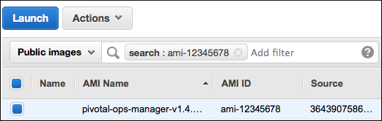

1. Select this AMI and click **Launch**.
2. Choose **m3.large** for your instance type.

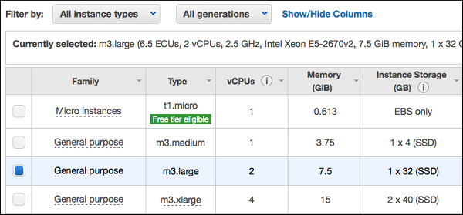

1. Click **Next: Configure Instance Details**.

## Step 3: Configure Instance Details

1. Complete the **Config Instance Details** page with information from the [Outputs tab](https://docs.pivotal.io/pivotalcf/1-10/customizing/cloudform-om-deploy.html#outputs) in the AWS Stacks Dashboard:

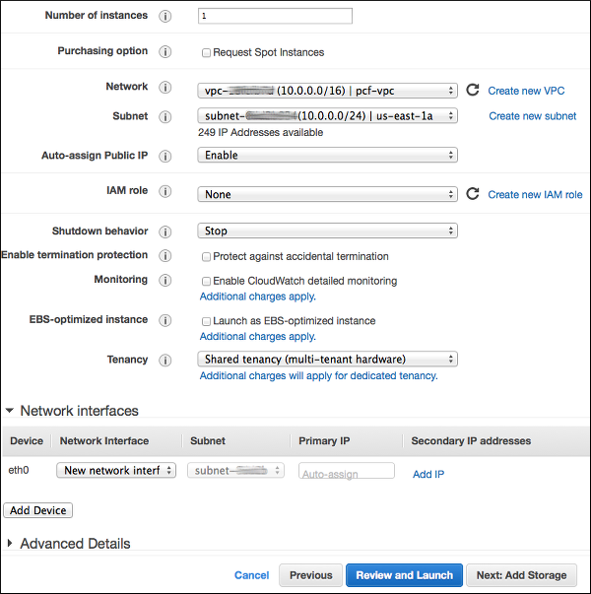

* + Select the **Network** that matches the value of **PcfVpc**.
  + Select the **Subnet** that matches the value of **PcfPublicSubnetId**.

1. Set **Auto-assign Public IP** to **Enable**.
2. Click **Next: Add Storage**.
3. On the **Add Storage** page, adjust the **Size (GiB)** value. Pivotal recommends increasing this value to a minimum of 100 GB.

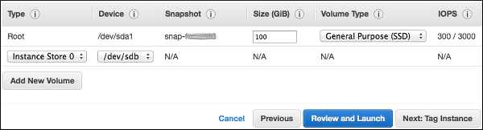

1. Click **Next: Tag Instance**.
2. On the **Tag Instance** page, add a **Key** Name with **Value** Ops Manager.

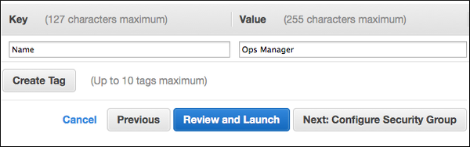

1. Click **Next: Configure Security Group**.

## Step 4: Configure Security Group

1. Select the **Select an existing security group** option.
2. Select the **Security Group ID** that matches the value of **PcfOpsManagerSecurityGroupId** located in the [Outputs](https://docs.pivotal.io/pivotalcf/1-10/customizing/cloudform-om-deploy.html#outputs) tab of the Stacks dashboard. 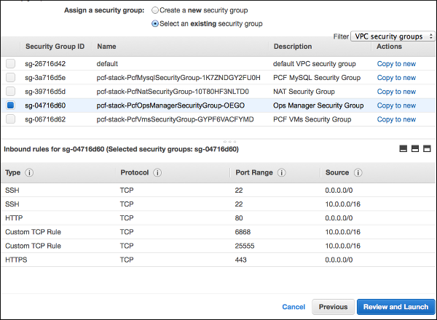
3. Click **Review and Launch**.

## Step 5: Deploy Ops Manager

1. Review the instance launch details. Click **Launch**.

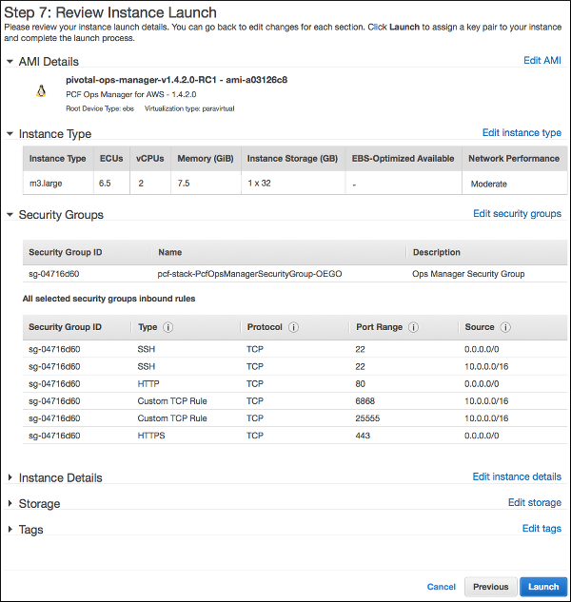

1. Use the first drop-down menu to select **Choose an existing key pair**. Use the second drop-down menu to select the name of your pre-existing AWS key pair.
2. Select the acknowledgement checkbox.
3. Click **Launch Instances**. If successful, you will see the **Launch Status Page**.

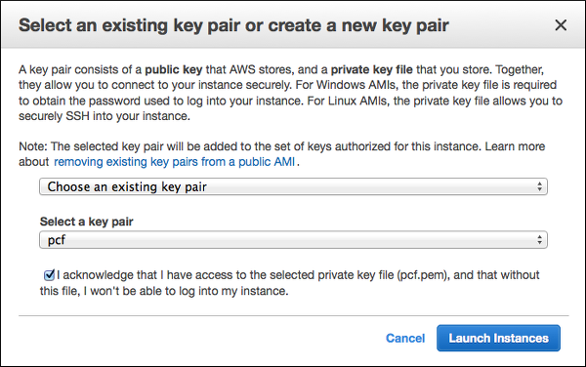

1. Click **View Instances**. Or alternately, navigate to **Instances** from the left navigation panel of the EC2 Dashboard.
2. AWS deploys Ops Manager. This may take a few minutes. When complete, AWS displays an **Instance State** of running and a **Status Check** of passed when the Ops Manager deployment successfully completes. 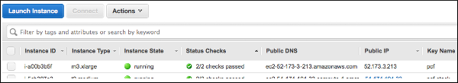

## Step 6: Create a DNS Entry

**Note**: For security, Ops Manager 1.7 and later require that you log in using a fully qualified domain name during the [initial configuration.](https://docs.pivotal.io/pivotalcf/1-10/customizing/cloudform-om-config.html)

Create a DNS entry for the IP address that you used for Ops Manager. You must use this fully qualified domain name when you log into Ops Manager in the Configure Ops Manager Director for AWS step below.

## Step 7: Configure Ops Manager Director for AWS

## Step 1: Open the Outputs Tab in AWS Stacks

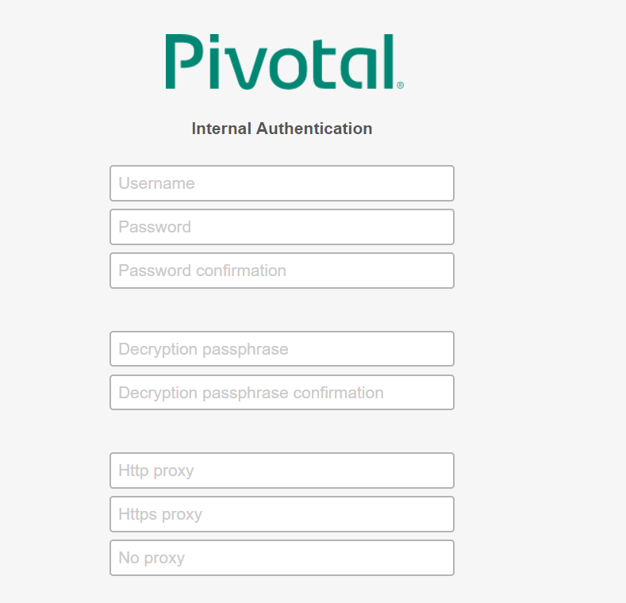

Uname : sushil

Pwd: sushil123

Passphrase: sushil

# Deploying Elastic Runtime on AWS

* [Step 1: Open the Outputs Tab in AWS](https://docs.pivotal.io/pivotalcf/1-10/customizing/cloudform-er-config.html" \l "open-outputs)
* [Step 2: Add Elastic Runtime to Ops Manager](https://docs.pivotal.io/pivotalcf/1-10/customizing/cloudform-er-config.html#add-er)
* [Step 3: Assign Availability Zones and Networks](https://docs.pivotal.io/pivotalcf/1-10/customizing/cloudform-er-config.html#assign-az)
* [Step 4: Add CNAME Record for Your Custom Domain](https://docs.pivotal.io/pivotalcf/1-10/customizing/cloudform-er-config.html#cname)
* [Step 5: Configure Domains](https://docs.pivotal.io/pivotalcf/1-10/customizing/cloudform-er-config.html#er-domain-config)
* [Step 6: Configure Networking](https://docs.pivotal.io/pivotalcf/1-10/customizing/cloudform-er-config.html#networking)
* [Step 7: Configure Application Containers](https://docs.pivotal.io/pivotalcf/1-10/customizing/cloudform-er-config.html#application-containers-config)
* [Step 8: Configure Application Developer Controls](https://docs.pivotal.io/pivotalcf/1-10/customizing/cloudform-er-config.html#er-appdevctrl-config)
* [Step 9: Review Application Security Groups](https://docs.pivotal.io/pivotalcf/1-10/customizing/cloudform-er-config.html#app-security)
* [Step 10: Configure Authentication and Enterprise SSO](https://docs.pivotal.io/pivotalcf/1-10/customizing/cloudform-er-config.html#er-auth-config)
* [Step 11: Configure System Databases](https://docs.pivotal.io/pivotalcf/1-10/customizing/cloudform-er-config.html#sys-db)
  + [Internal Database Configuration](https://docs.pivotal.io/pivotalcf/1-10/customizing/cloudform-er-config.html#internal-db)
  + [Create External System Databases](https://docs.pivotal.io/pivotalcf/1-10/customizing/cloudform-er-config.html#create-dbs)
* [Step 12: (Optional) Configure Internal MySQL](https://docs.pivotal.io/pivotalcf/1-10/customizing/cloudform-er-config.html#internal-mysql)
* [Step 13: Configure File Storage](https://docs.pivotal.io/pivotalcf/1-10/customizing/cloudform-er-config.html#filestore)
  + [Internal Filestore](https://docs.pivotal.io/pivotalcf/1-10/customizing/cloudform-er-config.html#internal_filestore)
  + [External S3 or Ceph Filestore](https://docs.pivotal.io/pivotalcf/1-10/customizing/cloudform-er-config.html#external_s3)
  + [Other IaaS Storage Options](https://docs.pivotal.io/pivotalcf/1-10/customizing/cloudform-er-config.html#other)
* [Step 14: (Optional) Configure System Logging](https://docs.pivotal.io/pivotalcf/1-10/customizing/cloudform-er-config.html#sys-logging)
* [Step 15: (Optional) Customize Apps Manager](https://docs.pivotal.io/pivotalcf/1-10/customizing/cloudform-er-config.html#customize-apps-man)
* [Step 16: (Optional) Configure Email Notifications](https://docs.pivotal.io/pivotalcf/1-10/customizing/cloudform-er-config.html#smtp)
* [Step 17: (Optional) Add CCDB Restore Key](https://docs.pivotal.io/pivotalcf/1-10/customizing/cloudform-er-config.html#ccdb-key)
* [Step 18: Configure Smoke Tests](https://docs.pivotal.io/pivotalcf/1-10/customizing/cloudform-er-config.html#config-smoke-test)
* [Step 19: (Optional) Enable Advanced Features](https://docs.pivotal.io/pivotalcf/1-10/customizing/cloudform-er-config.html#advanced-features)
* [Step 20: Configure Errands](https://docs.pivotal.io/pivotalcf/1-10/customizing/cloudform-er-config.html#errands)
* [Step 21: Configure Router to Elastic Load Balancer](https://docs.pivotal.io/pivotalcf/1-10/customizing/cloudform-er-config.html#config-elb)
* [Step 22: (Optional) Disable Unused Resources](https://docs.pivotal.io/pivotalcf/1-10/customizing/cloudform-er-config.html#disable-resources)
* [Step 23: Download Stemcell](https://docs.pivotal.io/pivotalcf/1-10/customizing/cloudform-er-config.html#stemcell)
* [Step 24: Complete the Elastic Runtime Installation](https://docs.pivotal.io/pivotalcf/1-10/customizing/cloudform-er-config.html#complete)

## Step 1: Open the Outputs Tab in AWS

1. In the dashboard of your [AWS Console](https://console.aws.amazon.com/), click **CloudFormation**. The Stacks Dashboard displays.
2. Select the **pcf-stack** checkbox, then select the **Outputs** tab.

## Step 2: Add Elastic Runtime to Ops Manager